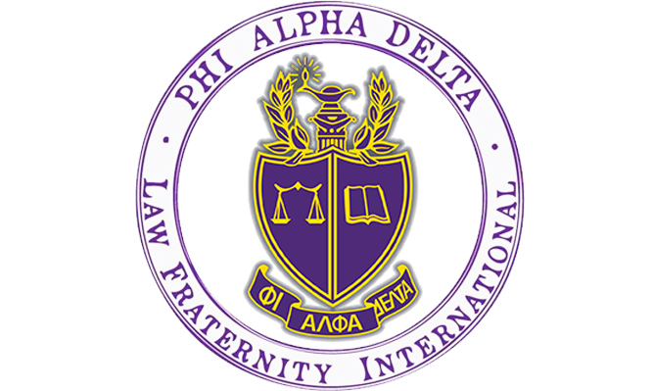

Are you thinking about going to law school? Do you want to help your community and learn how to be a dedicated attorney?

Phi Alpha Delta is the place for you!

**What is PAD?** PAD is a co-ed Pre-Law organization for the lawyers of the future. Our chapter at the University of Colorado Boulder is ranked number three in the nation among recruiting chapters. The Tuesday Talks Program was also named the top professional law program in the country by Phi Alpha Delta International in 2021!

**What do members of PAD do?**

1. Attend weekly Nationally Acclaimed Tuesday Talks Program – including attorneys, law school admission deans and directors, and judges across the country, sponsored by the University of Colorado Boulder Pre-Law Office and Phi Alpha Delta.
2. Participate in local fundraisers with your favorite restaurants!
3. Engage with philanthropies to help your community through local organizations!
4. Get a chance to go to Washington, D.C. for free with fellow PAD members. Attend our Annual Colorado Law Fair each fall with over 100 law schools participating.
5. Receive exclusive discounts to LSAT Prep Courses!

**Let’s Get in Touch!**

PAD is co-sponsored by the **CU Boulder Pre-Law Office.**

**Anthony Bastone**

Program Manager

Academic Advisor/Prelaw

Phi Alpha Delta Faculty Advisor

Dean Emeritus – Career Development

University of Colorado Law School

**Phone:** 303- 775-6321

**Email:** [anthony.bastone@colorado.edu](mailto:anthony.bastone@colorado.edu)

**Website:** <http://www.colorado.edu/advising/pre-law>

**Office:** Remote – Appointments via Buff Portal

**Tuesday Talks Speaker Schedule – Fall 2025**

|  |  |
| --- | --- |
| **Tuesday Date** | **Guest Speaker/Speakers** |
| August 26th - 2025 | **Pamela Toscano – Associate Director of Admissions – Harvard Law School – Cambridge, Massachusetts** |
| September 2nd - 2025 | **Danae Baldwin – Associate Director Admissions – UCLA School of Law – Los Angeles, California – Stephen Perez – Director of Admissions - University of Texas School of Law – Austin Texas – Shane Cooper – Senior Associate Dean - Admissions, Financial Aid & Student Services – Cornell Law School – Ithaca, New York – Matthew Dillard – Director of Admissions & Professional Lecturer in Law – George Washington University Law School – Washington DC** |
| September 9th -2025 | **Amy Best – Assistant Dean Admissions & Financial Aid – Sandra Day O’Connor College of Law – Arizona State University -Phoenix, AZ** |
| September 16th - 2025 | **Interim Dean of Admissions Lindsay Victoria Chuang & Lisa Carlock Associate Director Career Services – University of California Davis School of Law (King Hall)– Davis, CA** |
| September 23rd - 2025 | **Jen Smith – Associate Director Admissions -University of Colorado Law School – Boulder, CO** |
| September 30th - 2025 | **Robin Ingli – Assistant Dean of Admissions – Kate Snowdon – Director of Admissions & Student Ambassadors – University of Minnesota Law School – Minneapolis, MN** |
| October 7th – 2025 | **Jon Perdue – Director of Recruiting & Community Engagement – Yale Law School – New Haven, CT** |
| October 14th - 2025 | **Jason Owen – Assistant Dean of Admissions – University of Utah S. J. Quinney College of Law – Salt Lake City, UT** |
| October 21st - 2025 | **Greg Canada – Assistant Dean for Admissions – Indiana University Maurer School of Law – Bloomington, IN** |
| October 28th - 2025 | **Noah Koester – Assistant Director of Law Admissions – Rutgers Law School – Newark, NJ** |
| November 4th - 2025 | **Roscoe Jones – Dean – Drake University Law School – Des Moines, IA** |
| November 18th - 2025 | **Aubrie Bailie – Assistant Director of Compliance & Legal Operations – Georgia Tech Athletic Association – Atlanta, GA** |
| November 25th - 2025 | **Pamela Civins – Peace Corps Strategic Campus Recruiter – University of Colorado Boulder – Boulder, CO** |

**How do I join Tuesday Talks?**

* **Recurring Link:** <https://cuboulder.zoom.us/j/99742846893>
* **Time:** All Tuesday Talks will begin 5:30pm MST via Zoom

**Contact us!**

Dean Emeritus Anthony Bastone | Program Manager and Academic Advisor for Pre-Law & Faculty

Advisor Phi Alpha Delta - Email: [anthony.bastone@colorado.edu](mailto:anthony.bastone@colorado.edu)

Reagan Campbell Phi Alpha Delta President

Email: [Reagan.Campbell@colorado.edu](mailto:Reagan.Campbell@colorado.edu)

Chloe Garrier Phi Alpha Delta Vice President

Email: [Chloe.Garrier@colorado.edu](mailto:Chloe.Garrier@colorado.edu)

Ava Richardson Phi Alpha Delta Secretary

[Ava.Richardson@colorado.edu](mailto:Ava.Richardson@colorado.edu)

Grace Lynch Phi Alpha Delta Treasurer

[Grace.Lynch-1@colorado.edu](mailto:Grace.Lynch-1@colorado.edu)

Reagan Campbell | Phi Alpha Delta Secretary

Email: [Reagan.Campbell@colorado.edu](mailto:Reagan.Campbell@colorado.edu)

Ethan Shea | Phi Alpha Delta Treasurer

Email: [Ethan.Shea@colorado.edu](mailto:Ethan.Shea@colorado.edu)

Email: [william.aylott@colorado.edu](mailto:william.aylott@colorado.edu)