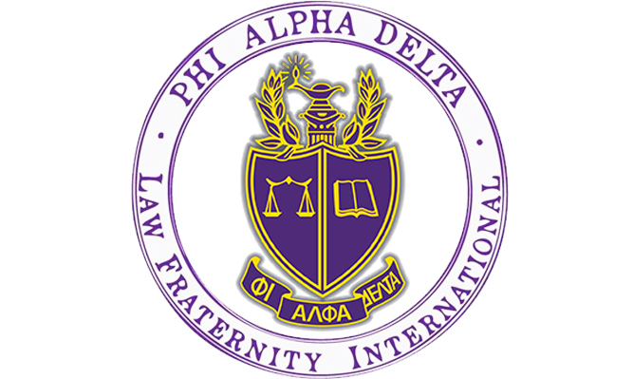

Are you thinking about going to law school? Do you want to help your community and learn how to be a dedicated attorney?

Phi Alpha Delta is the place for you!

**What is PAD?** PAD is a co-ed Pre-Law organization for the lawyers of the future. Our chapter at the University of Colorado Boulder is ranked number three in the nation among recruiting chapters. The Tuesday Talks Program was also named the top professional law program in the country by Phi Alpha Delta International in 2021!

**What do members of PAD do?**

1. Attend weekly Nationally Acclaimed Tuesday Talks Program – including attorneys, law school admission deans and directors, and judges across the country, sponsored by the University of Colorado Boulder Pre-Law Office and Phi Alpha Delta.
2. Participate in local fundraisers with your favorite restaurants!
3. Engage with philanthropies to help your community through local organizations!
4. Get a chance to go to Washington, D.C. for free with fellow PAD members. Attend our Annual Pre-Law Fair each fall with over 100 law schools participating.
5. Receive exclusive discounts to LSAT Prep Courses!

**Let’s Get in Touch!**

PAD is co-sponsored by the **CU Boulder Pre-Law Office.**

**Anthony Bastone**

Program Manager

Academic Advisor/Prelaw

Phi Alpha Delta Faculty Advisor

**Phone:** 303- 775-6321

**Email:** [anthony.bastone@colorado.edu](mailto:anthony.bastone@colorado.edu)

**Website:** <http://www.colorado.edu/advising/pre-law>

**Office:** Remote – Appointments via Buff Portal

**Tuesday Talks Speaker Schedule | Spring 2025**

|  |  |
| --- | --- |
| **Tuesday Date** | **Guest Speaker/Speakers** |
| January 14th - 2025 | **Kristi Jobson – Assistant Dean for Admissions & Chief Admissions Officer - Harvard Law School – David Kidd – Skadden, Arps, Slate, Meagher & Flom – New York City, NY – Berkeley Newhouse-Velie CU Boulder Graduate and 3L student Harvard Law School** |
| January 21st - 2025 | **Chris Bailey – Assistant Dean of Admissions & Financial Aid – University of Washington School of Law – Seattle, WA – Amy Karen Liden 1L – Graduate – University of Colorado Boulder – Boulder, CO** |
| January 28th – 2025 | **Kathy Sulentic Attorney & Deputy Athletic Director, Regulatory Affairs – The University of Memphis – Memphis TN** |
| February 4th - 2025 | **Sean Reilly – Assistant Dean for Admissions – Marquette University Law School – Milwaukee, WI** |
| February 11th - 2025 | **Jen Smith – Assistant Director Admissions – University of Colorado Law School – Boulder, CO** |
| February 18th – 2025 | **Josie Hollenbaugh – Associate Director of Admissions – Gonzaga University School of Law – Spokane, WA** |
| February 25th - 2025 | **Katrin Hussmann Schroll – Assistant Dean Admissions – Joseph P. Matthews – Director of Student Recruitment – University of Miami School of Law – Coral Gables, FL** |
| March 4th - 2025 | **Anne Taylor – Assistant Dean Admissions & Chloe Mathews – Senior Associate Director of Admissions - Boston University School of Law – Boston, MA** |
| March 11th - 2025 | **Professor Eric Klinger – Faculty Director – Writing Center – University of Colorado Boulder** |
| March 18th - 2025 | **Assistant Dean of Admissions – Joseph Lindsay – University of California Berkeley, School of Law – Berkeley, CA** |
| March 25th - 2025 | **SPRING BREAK** |
| April 1st - 2025 | **Nicholas Pavich – Attorney/LSAT Consultant – Boulder LSAT – Boulder, CO** |
| April 8th - 2025 | **Noah Koester – Assistant Director of Admissions – Rutgers Law School – Newark, NJ** |

**How do I join Tuesday Talks?**

* **Recurring Link:** <https://cuboulder.zoom.us/j/99742846893>
* **Time:** All Tuesday Talks will begin 5:30pm MST via Zoom

**Contact us!**

Dean Emeritus Anthony Bastone | Program Manager and Academic Advisor for Pre-Law & Faculty

Advisor Phi Alpha Delta - Email: [anthony.bastone@colorado.edu](mailto:anthony.bastone@colorado.edu)

Kiera Fyfe| Phi Alpha Delta President

Email: [Kiera.Fyfe@coloradfo.edu](mailto:Kiera.Fyfe@coloradfo.edu)

Katherine MacLean | Phi Alpha Delta Vice President

Email: [Katherine.MacLean@colorado.edu](mailto:Katherine.MacLean@colorado.edu)

Reagan Campbell | Phi Alpha Delta Secretary

Email: [Reagan.Campbell@colorado.edu](mailto:Reagan.Campbell@colorado.edu)

Ethan Shea | Phi Alpha Delta Treasurer

Email: [Ethan.Shea@colorado.edu](mailto:Ethan.Shea@colorado.edu)

Email: [william.aylott@colorado.edu](mailto:william.aylott@colorado.edu)