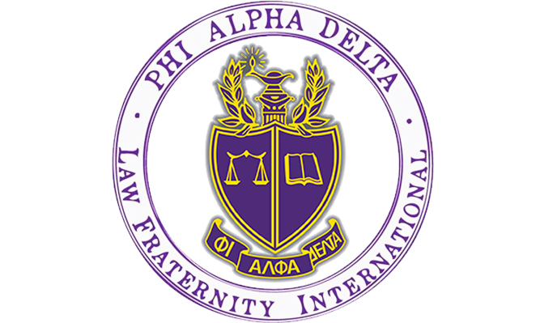

Are you thinking about going into law? Do you want to help your community and learn how to be a dedicated attorney?
Phi Alpha Delta is the place for you!
PAD is a co-ed Pre-Law organization for the lawyers of the future.

- Weekly Tuesday Talks from lawyers, law schools, and judges across the country, sponsored by the University of Colorado Boulder Pre-Law Office!
- Local fundraisers with your favorite restaurants!
- Philanthropies to help your community through local organizations!
- A chance to go to Washington, D.C. free with fellow PAD members. Attend our Annual Pre-Law Fair each fall with over 100 law schools participating.
- Exclusive discounts to LSAT Prep Courses!
- Number three in the nation among recruiting chapters with 109 members in 2016!

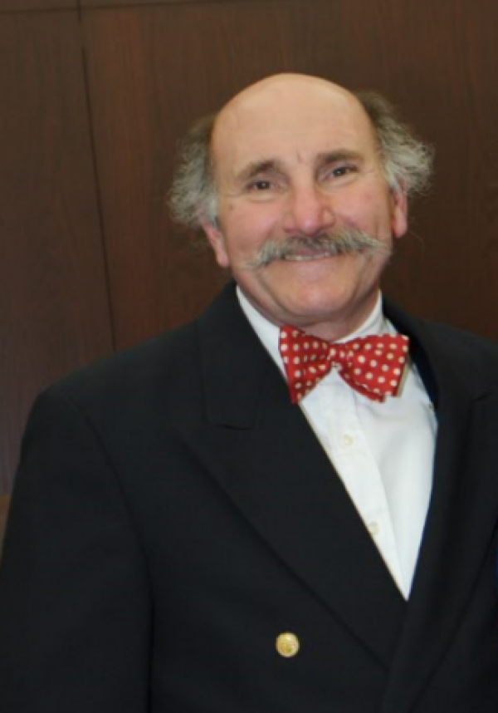
Co-sponsored by the
CU Boulder Pre-Law Office:

Anthony Bastone
Program Manager
Academic Advisor/Prelaw & Program Manager
Phi Alpha Delta Faculty Advisor
http://www.colorado.edu/advising/pre-law

303-775-6321 – Cell
Email: anthony.bastone@colorado.edu

Tuesday Talk – Recurring Link
https://cuboulder.zoom.us/j/99742846893

Tuesday Talks Speaker Schedule
Spring 2023

All events held at 5:30 PM MST via zoom

Recurring Link - https:cuboulder.zoom.us/j/99742846893

1/17/23 – Andrew Strauss – Dean University of Dayton School of Law, Dayton Ohio

1/24/23 – Lauren Burkett – Assistant Dean of Admissions – Arizona State University – Sandra Day O’Connor School of Law – Phoenix Arizona

1/31/23 – Christina Arteaga – Assistant Dean of Admissions – University of Washington School of Law – Seattle Washington

2/14/23 – Dexter Smith – Assistant Dean of Admissions – Emory University School of Law, Atlanta Georgia

2/21/23 – Diane DeJesus – Assistant Director of Admissions and Student Experience – University of Georgia School of Law, Athens Georgia

2/28/23 – Sarah Keiski Assistant Dean Student Affairs & Jessica Mason 3L – University of Oregon School of Law & graduate of University of Colorado Boulder
3/7/23 –Tracy Simmons Assistant Dean – Admissions, Diversity Initiatives& Financial Aid Michael Chavez – Director of Admissions – University of San Diego School of Law, San Diego, CA

3/14/23 – Susanne Vasic Corporate Counsel – CC Industries – Chicago, Illinois

3/21/23 – TBD

4/11/23 – TBD

4/18/23 – Alisa Leonard – Senior Assistant Dean for Admissions & Financial Aid - Boston University School of Law – Boston, MA

4/25/23 – TBD

______________________________________________________________________________

Questions about Phi Alpha Delta or the Pre-Law Office? Contact us:
Dean Anthony Bastone (Program Manager/Academic Advisor-Prelaw): anthony.bastone@colorado.edu
Sarah Rosenbloum (Phi Alpha Delta President): Sarah.Rosenbloum@colorado.edu
(Phi Alpha Delta Treasurer): William.Aylott@colorado.edu

(Secretary): jenna.goldstein@colorado.edu

