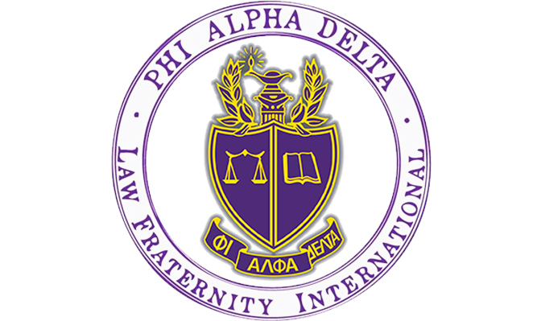

Are you thinking about going into law? Do you want to help your community and learn how to be a dedicated attorney?
Phi Alpha Delta is the place for you!
PAD is a co-ed Pre-Law organization for the lawyers of the future.

- Weekly Tuesday Talks from lawyers, law schools, and judges across the country, sponsored by the University of Colorado Boulder Pre-Law Office!
- Local fundraisers with your favorite restaurants!
- Philanthropies to help your community through local organizations!
- A chance to go to Washington, D.C. free with fellow PAD members. Attend our Annual Pre-Law Fair each fall with over 100 law schools participating.
- Exclusive discounts to LSAT Prep Courses!
- Number three in the nation among recruiting chapters with 109 members in 2016!

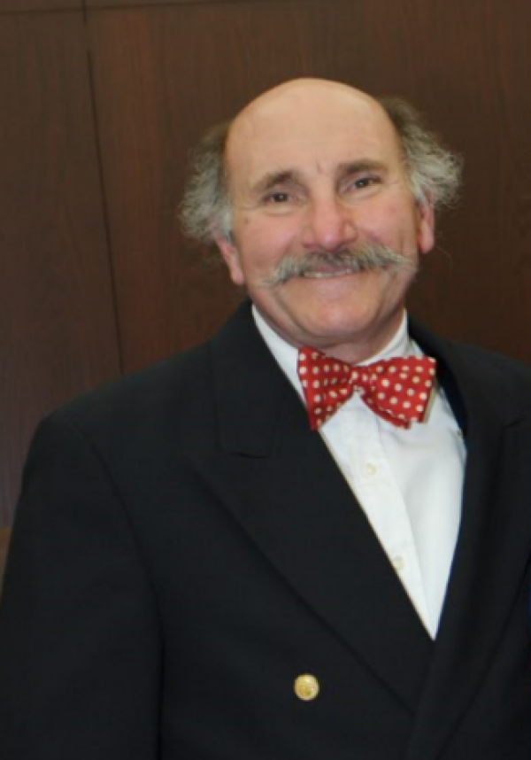
Co-sponsored by the
CU Boulder Pre-Law Office:

Anthony Bastone
Program Manager
Academic Advisor/Prelaw
Phi Alpha Delta Faculty Advisor
http://www.colorado.edu/advising/pre-law
Center for Community, Room S454
Tel: 303-492-3474 (direct)
303-492-6541 (office)
Email: anthony.bastone@colorado.edu

Tuesday Talk – Recurring Link
https://cuboulder.zoom.us/j/99742846893

Tuesday Talks Speaker Schedule
Spring 2021

All events held at 5:30 PM via zoom

Recurring Link - https:cuboulder.zoom.us/j/99742846893

1/19/21 – Mathiew Le - Assistant Dean of Admissions & Financial Aid – University of Texas at Austin School of Law
1/26/21 – Todd Hicks – CU Alumnus & Deputy District Attorney – Los Angeles, CA
2/16/21 – Natalie Blazer – Assistant Dean of Admissions – University of Virginia School of
Law – Charlottesville, VA
2/23/21 – Amy Bockman – County Judge – Seventeenth Judicial District – Broomfield, CO

3/2/21 – Katherine Sulentic – NCAA Sports Attorney – Indianapolis, IN

3/9/21 – CU 1L Law Student Panel – Kylie Ngu, Joseph Verran & Danielle Edwards

3/22/21-Deadline to vote in PAD Elections

3/30/21 – Ann-Marie Moyes – CU Law Director Korey Wise Innocence Project

4/13/21 – Paul Bokota Vice President - General Counsel – Hydrafacial – Long Beach, CA

4/20/21 – TBD

4/27/21 - TBD
______________________________________________________________________________

Questions about Phi Alpha Delta or the Pre-Law Office? Contact us:
Dean Anthony Bastone (Program Manager/Academic Advisor-Prelaw): anthony.bastone@colorado.edu
Berkley Newhouse-velie (Phi Alpha Delta President):
berkeley.newhouse-velie@colorado.edu
(Phi Alpha Delta Treasurer): stephanie.morita@colorado.edu

(Secretary): jenna.goldstein@colorado.edu

